|  |  |
| --- | --- |
|  |  |

**Front End I TERM PROJECT**

**On**

**Website: Eventify**

[**https://eventify1.netlify.app/**](https://eventify1.netlify.app/)

**Submitted By:**

Ajaya Prajapati (C0886029)  
Angrej Singh (C0884026)   
Manmeet Kaur (C0884039)  
Ravleen Kaur (C0886426)  
Riya Sidhu (C0886435)

**Submitted To:**

Mehrnoush Ashrafi

1. What is the Purpose of the Website?

Our website serves as a platform for marketing and managing numerous events, including parties, concerts, festivals, exhibitions, job fair and sporting events. The website acts as a central hub where event planners may advertise their future events, provide information about the events, including the date, time, location, cost, and sponsorship options, and let attendees sign in, buy tickets, and get updates about the event. The features and services offered by our website can also include online ticketing, tools for managing events, social media integration and networking possibilities for visitors, sponsors, and exhibitors.

1. Who is the Target Audience?

* **Event Attendees:** These are people who are considering going to the event and are seeking for information about the timetable, location, cost of tickets, and other specifics.
* **Event Sponsors:** Event sponsors are businesses or organizations interested in supporting the event and want further information about the available sponsorship opportunities.
* **Event Exhibitors:** These are companies or organizations asking for information about the exhibition space and other specifics because they want to display their goods or services at the event.
* **Event Organizers:** These are the people or organizations in charge of organizing the event, and they require tools and services to effectively promote and run the event.
* **Media and Press**: These are reporters, bloggers, and other media professionals who want to cover the event but need knowledge and materials to do so.
* **Other Stakeholders:** These might be governmental bodies, nonprofits, or other organizations with a stake in the occasion, including neighborhood associations or advocacy groups.

1. How many pages will be included in your website?

There are 4 webpages on our website:

* Home page
* Events
* Services
* About us

1. What graphics will you use on the website?

The graphics that we have used in the website are image icons, images, and videos.

1. What colors (color scheme) will you use on the website?

We have used mainly black n white color schemes on our website.

1. What font styles will you use within the website?

Lato Font style has been used in the Website

1. What features will be displayed on the webpages?

* **Event booking**: The website includes the event page that displays all the upcoming events along with their details such as venue, time, date, and price. It also provides the user option to purchase the ticket for the desired event.
* **Services**: Our website provides the customer with various services which include videography, ticketing, event planning, music decors and rentals, catering, photography, etc.
* **Sign in**: This feature is provided so that users can log in to the website and enjoy the event services including ticket booking etc.
* **Contact Form**: This form provides users with the option to send their inquiries.

SITEMAP

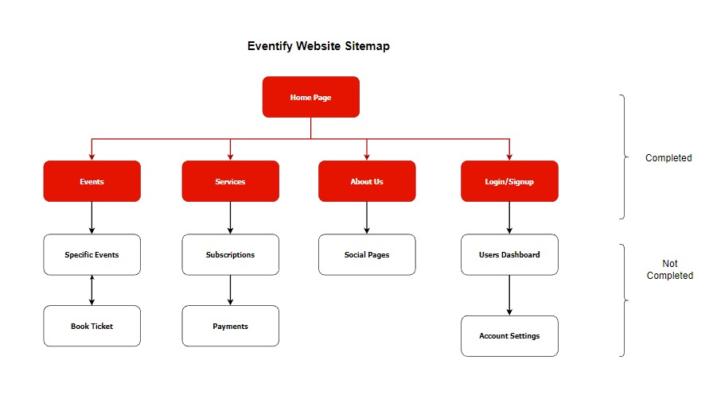

Figure 1 Site Map of the Website

WIREFRAME

For Desktop:

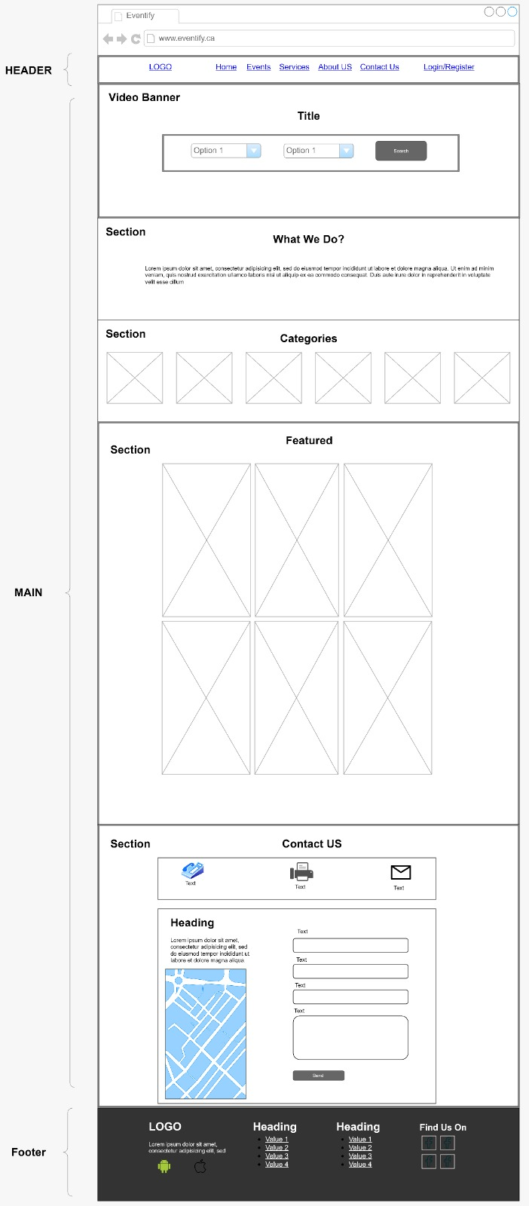

Figure 2 Home Page

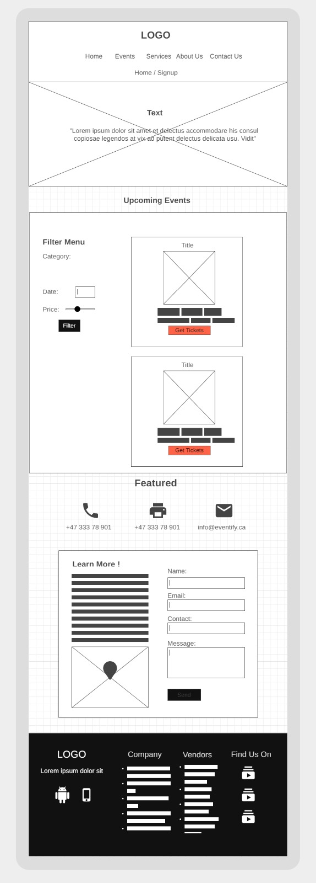

Figure 3 Events Page

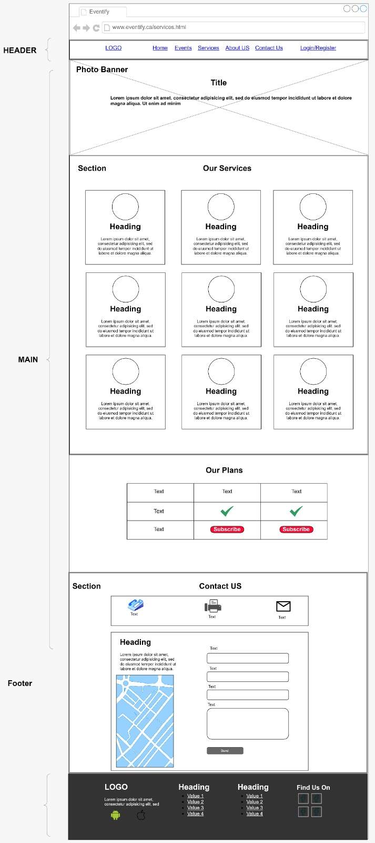

Figure 4 Services Page

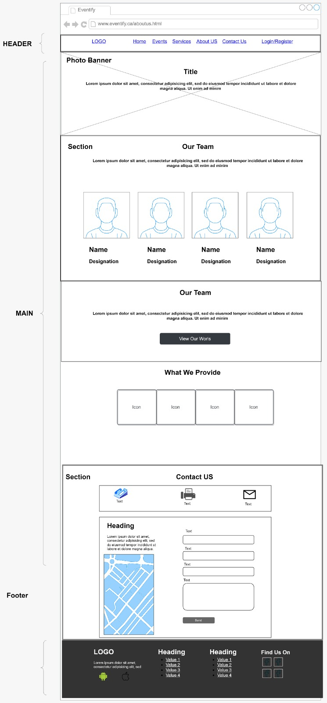

Figure 5 About Us Page

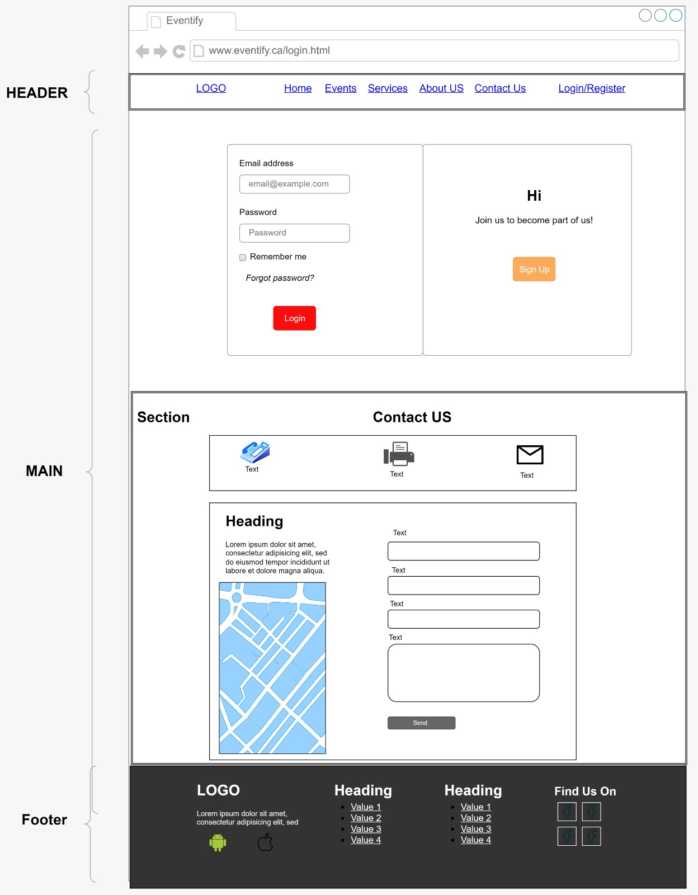

Figure 6 Login Page

For Tablet/ Mobile:

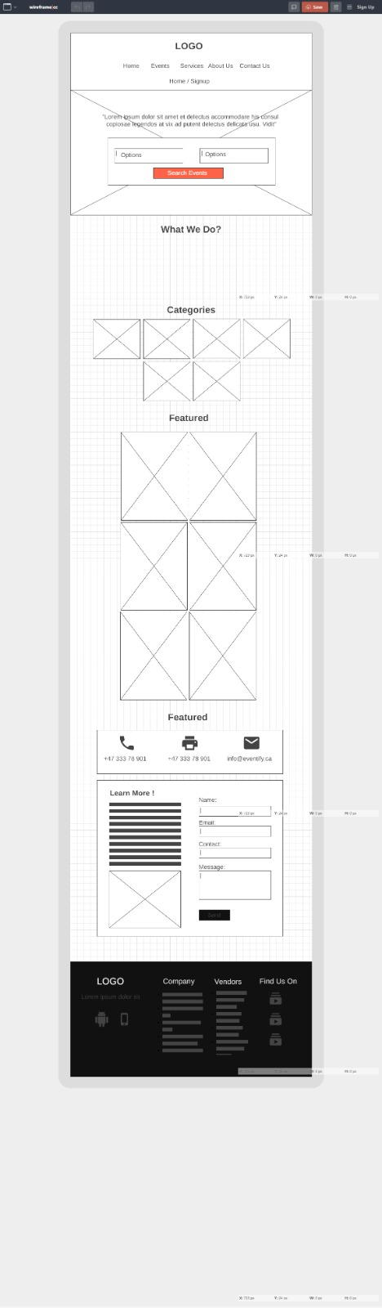

Figure 7 Home Page



Figure 8 Events Page

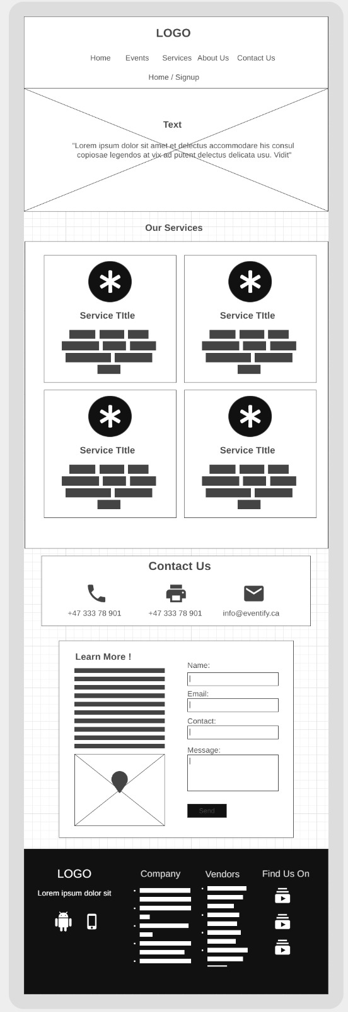

Figure 9 Services Page

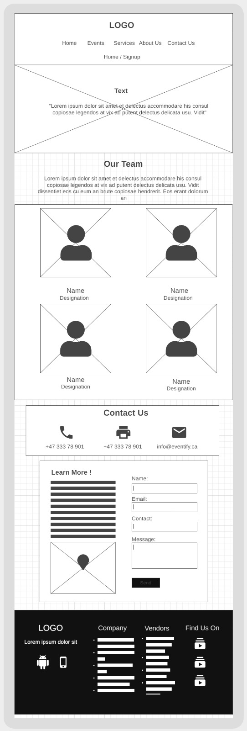

Figure 10 About Us Page

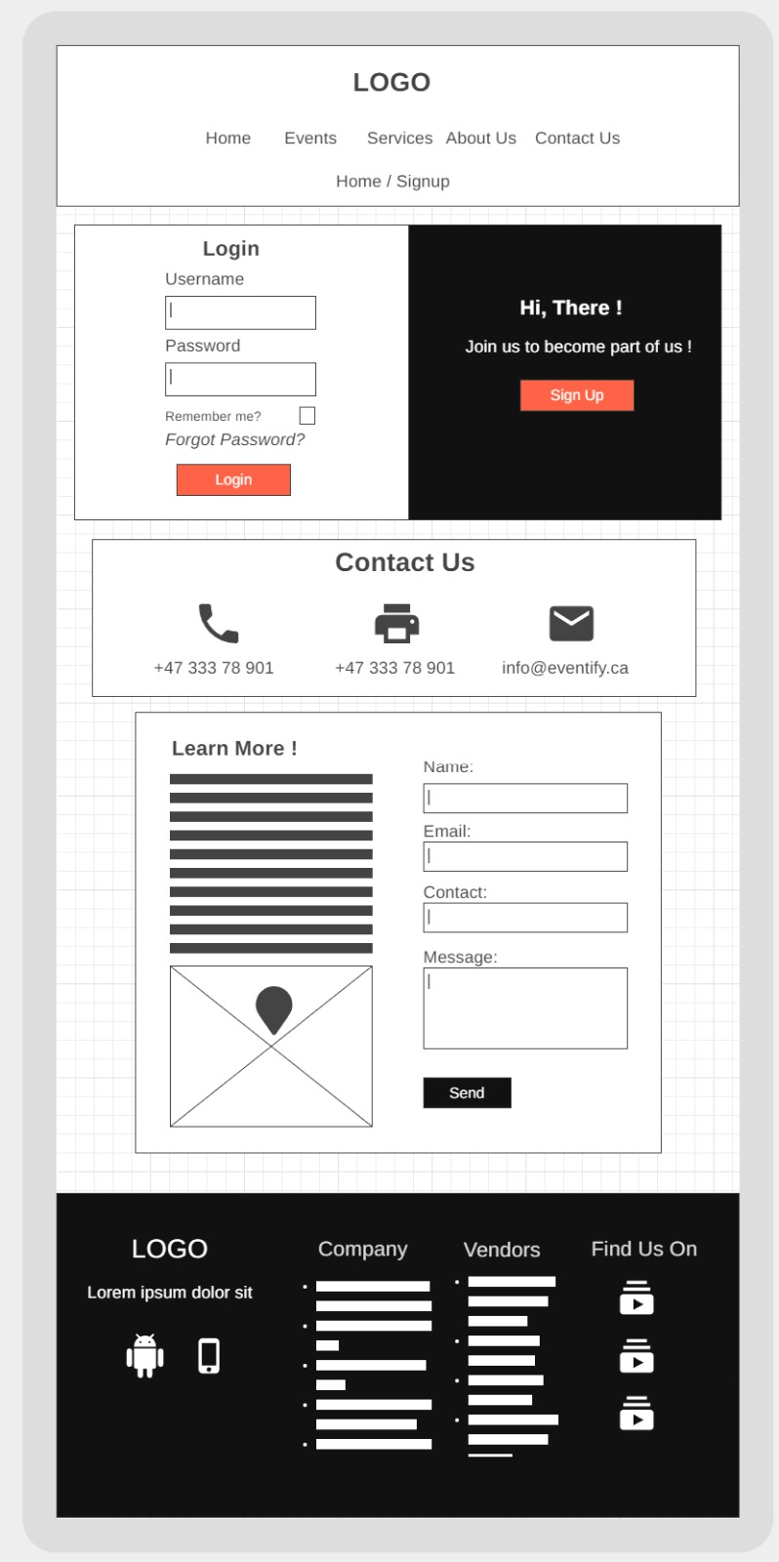

Figure 11 Login Page